**PROJECT DESIGN PHASE -2**

Solution Requirement (Functional & Non- Functional)

|  |  |
| --- | --- |
| DATE | 15 OCTOBER 2022 |
| TEAM ID | PNT2022TMID36938 |
| PROJECT | SMART FASHION RECOMMENDER APPLICATION |
| MAXIMUM MARK | 4 Marks |

**FUNCTIONAL REQUIREMENT:**

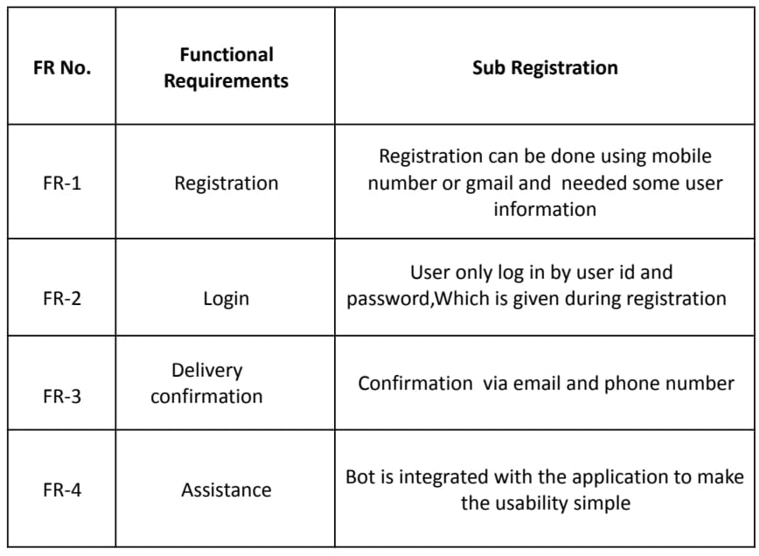

**NON- FUNCTIONAL REQUIREMENT:**

